Savory Seafood Recipes and
Seafood Buying and Cooking Guide

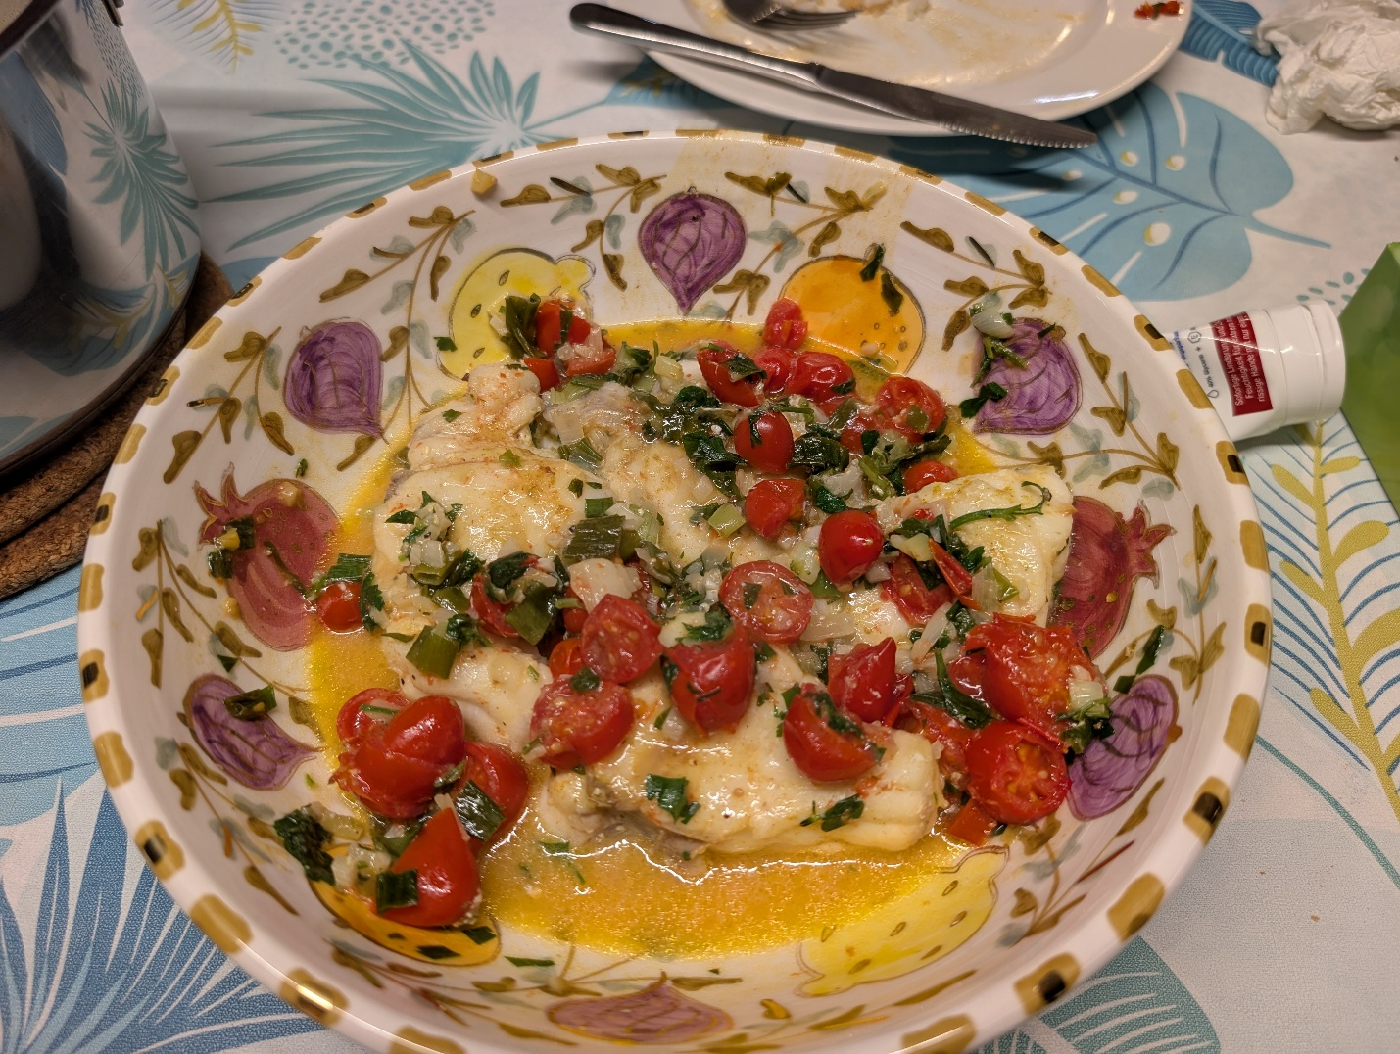

Bradley G. Stevens

This document is an accompaniment to my class “Savory Sustainable Seafood”. It summarizes some of the important information from that class, including simple steps to sourcing, buying, cooking, and eating seafood that can help lead to better health and nutrition.
Buying Fish
- Buy Fresh (If possible).
- Buy frozen if you can’t buy fresh. This is the best method for imported fish, and for w ild salmon, halibut, mahi-mahi, and ahi tuna.
- Buy Local. Locally caught seafood will be the freshest, and supports your local fishing community. On the Eastern Shore, local seafoods include black sea bass, flounder, rockfish (striped bass), blue catfish, blue crab, oysters, scallops, and clams.
- Buy Regional. If you can’t find locally caught fish, buy some that are caught within a few hundred miles. In our region, that includes tuna, swordfish, mahi-mahi, lobster, grouper, and snapper.
- Buy Sustainable. Look for certifications from Seafood Watch, the Marine Stewardship Council, and the Aquaculture Stewardship Council. Visit their websites.

You Are What You Eat
Be careful and knowledgeable about the seafood that you eat. Use your power as a consumer to support best practices by selecting seafoods that are sustainable, have low environmental impacts, and contribute to the social welfare of people working in the fishing and processing industry.
- Eat Sparingly of the following, due to mercury levels: Swordfish, Tuna (Ahi, Bluefin)
- Try to avoid fried seafood, as it may be loaded with Omega-6 oils
- Don’t buy fish or shrimp breaded off-site (i.e., not in the restaurant). It may be contaminated with microplastics or PFA’s.
- Avoid raw seafood, unless it was previously deep-frozen.
- Try to eat fish close to its source. Even though it may be well preserved by deep-freezing, restaurants far from the source may not know how to prepare it well.
- Avoid buying non-sustainable seafood products. These include Jonah crab, Orange roughy, and possibly Chilean Sea bass (but this may be improving).
- Avoid buying shrimp from Thailand, or any seafood processed in China, due to concerns about human rights and enforced labor.

Is my fish Fresh?
When buying fish, ensure you get the best quality by asking questions and inspecting the product. When was it delivered? Was it frozen or fresh? Check your fish for the following:
Smell: The smell should be neutral, or slightly oceanic. Avoid anything that smells ‘fishy’, or like ammonia, which is due to the presence of trimethylamine.
Eyes should be clear, shiny, and bulging, but not cloudy
Gills should be moist, and bright red; not sticky, slimy, or gray
Skin should be smooth and shiny, with scales attached (though some may be de-scaled)
Slime is OK, but it should be clear and odorless
Flesh should be firm and moist, and bounces back from finger pressure, like memory foam. It should not be soft, have dry edges, or retain a finger depression.

Best and Worst
Here is a list of the best and worst of seafoods we discussed in class.
Category | Fish | Crustaceans | Molluscs
Highest Ω-3 | Mackerel, Herring, King Salmon, Sablefish | All low | All Low
Highest Mercury | Swordfish, Albacore | All Low | Low
Most Sustainable (Wild) | Salmon, Sablefish, Halibut | Snow crab | Sea scallop
Most Sustainable (Aquaculture) | Tilapia | Shrimp – tiger, whiteleg | Mussels, quahog (littleneck)
Least Sustainable | Bluefin Tuna | Jonah Crab | Bay scallop
Most Expensive | Chilean Sea Bass, King Salmon | Spiny Lobster, King Crab | Sea Scallop
Least Expensive | Sockeye Salmon, AT. Cod | Blue crab | Squid
Most Eco-impact | Orange Roughy | Farmed Shrimp | Oysters
Least Eco-impact | Tilapia | Snow crab | Mussels
Best Local | Striped Bass, Black Sea Bass, Summer Flounder | Blue Crab | Oysters
Best Regional | Albacore | Lobster | Sea Scallop
Best Taste (IMHO) | Ahi, King salmon, Toothfish | King crab | Sea Scallop

Simple Steps to Savory Seafood
This is NOT a cookbook. I am not much of a cook. But what I do cook is mostly seafood. If you want interesting and delicious recipes, there are many good seafood cookbooks available. I have tried many different recipes, but what I find works best is simple. I don’t usually plan my meals a day ahead or go to the grocery store with a list of specific items that will be rarely used. When I come home from work, I want to be able to fix dinner in a half-hour. I can’t do that with a recipe that requires unusual ingredients, so I work with what I have on hand. I always have frozen fish in my freezer, which may include salmon, halibut, Alaskan rockfish, and maybe some mahi-mahi. And I usually have enough ingredients to make a simple sauce or marinade. And that’s all you really need. This document includes some simple steps to making savory seafood dinners, without lots of fuss.
I have trouble following complicated recipes because everything is measured in different quantities. That’s the reason I did not become a chemist. I tend to gook by gestalt – a bit of this, a bit of that, maybe a bit more of something else. And I tend to use recipes that I can remember easily. I can’t remember specific measurements (1 Tbsp of this, and 2 tsp of that), but I do remember ratios, such as “use twice as much vinegar as oil”. I have included measured quantities in some of these recipes, but only as a guideline. Feel free to change them as you see fit.
The worst thing you can do to fish is overcook it. Almost all fish can be eaten raw, and some are better that way. I prefer not to eat raw salmon, though, because it can contain mammalian parasites, but they are destroyed by deep freezing. Raw fish is slightly translucent, so cook it until it just becomes opaque, or to about 125 °F. It won’t hurt to take it out of the oven (or the skillet) early, while the center is still a bit translucent, because it will continue to cook for a few minutes. I strongly recommend buying a digital meat thermometer to test your fish.
NOTE: Prying flakes out of the fish filets to test them leaves an ugly divot in your beautiful dish. It is better to use a digital thermometer. Lacking one, insert a fork gently into your fish; if it resists, it’s probably not done, but if it slides in easily, it’s done.
General Rules for Cooking Fish
- Cook within 2 days of purchase, or less if the fish is oily (eg., salmon)
- All fish can be baked, fried, grilled, or air-fried.
- Don’t overcook! Just cook until the fish is opaque and flaky, and between 120-135 °F
- Don’t oversauce. Fish have delicate flavors that are easily buried
- Freeze fresh fish for up to 6 months. It will keep up to a year if vacuum-sealed.

Sauces – the KISS approach
Simple Savory Sauces can be made with a few ingredients you probably have on hand. Mix these up while cooking the fish. If grilling, brush the sauce on after turning the fish flesh-side-up. If baking, spread the sauce on the plate, and place the fish on top of the sauce.
- Salt and Pepper – preferably fresh ground
- Oil or thickener
  - Butter
  - Olive, avocado
  - Mayonaise, yogurt, or cream
  - Honey
- Liquid
  - White wine
  - Lemon or lime juice
  - Coconut milk
- Flavor
  - Garlic, onion, shallots, ginger, wasabi
  - Soy or Teriyaki sauce
- Spices – 3 C’s : Cumin, coriander, curry
- Fresh Herbs: Dill, cilantro, parsley, basil

Recommended Books
These books will give you a lot of insight into the origins of your seafood, and how it is caught, processed, and marketed. They also tell a lot about the people involved in the fishing industry.
The Big Oyster – History on the Half Shell. Mark Kurlansky
Four Fish – The Future of the Last Wild Food. Paul Greenberg
Cod – The history and importance of an iconic fish. Mark Kurlansky
Billion-Dollar Fish: The Untold Story of Alaska Pollock. Kevin Bailey
Distant Water – The rise and fall of mid-Atlantic fish stocks. William Warner
Four Thousand Hooks – Halibut fishing in Alaska. Dean Adams
Beautiful Swimmers – Watermen, Crabs, and the Chesapeake Bay. William Warner
The Secret Life of Lobsters – How Fishermen and Scientists are unraveling the Mysteries of Our Favorite Crustacean. Trevor Corson
Skipjack – The Story of America’s Last Sailing Oystermen. Christopher White
Summer Harvest – Portrait of Commercial Crabbing on Chesapeake Bay. Doug Stephens

Broiled Salmon
This is the quickest, easiest way to cook salmon. The sauce is optional; others might work better for you. I used the underlined items. From https://www.washingtonpost.com/recipes/broiled-salmon-horseradish-sauce/

Dinner Ingredients
8-12 oz skin-on salmon fillets
8 oz French green beans OR Asparagus

Sauce Ingredients: Mix together (makes 2 servings)
1/2 cup plain Greek nonfat yogurt
2 Tbsp freshly grated horseradish OR 1 Tbsp Wasabi
3 Tbsp fresh lemon juice (1 lemon)
2 Tbsp chopped dill or chives
1 Tbsp whole-grain mustard
Freshly ground black pepper, Fine salt
2 Tbsp olive oil

Directions
Set oven rack 4- 6 inches from the broiler; preheat to HIGH.
Line a sheet pan with foil, and smear w/ 1 Tbsp olive oil.
Place salmon skin side up on sheet pan.
Toss the vegies with 1 Tbsp olive oil + salt, and place next to the salmon.
Broil for 4 min, check doneness. Skin lightly charred, flesh opaque, barely flaking; vegies should be blistered and tender. Broil another minute if needed.
Spread 1/4 cup of sauce on plates; top with a salmon fillet and vegies.

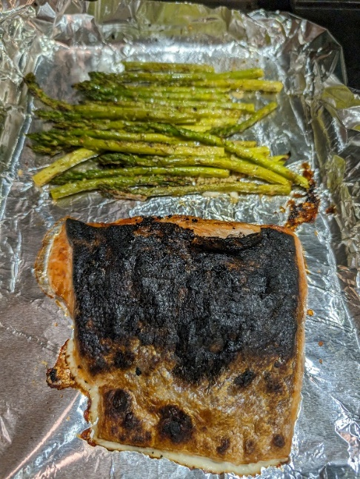

Grilled Fish

Grilling works really well for firm fish like salmon, swordfish, mahi-mahi. Whitefish, like rockfish and halibut, tend to separate, so if you grill them, do so on a piece of aluminum foil.

Thaw fish to room temperature, in the refrigerator overnight or in water (bagged) at 60 °F. Rinse in freshwater and pat dry.
If you marinade, soak it for 15-30 min before cooking. Or coat with olive oil and salt.
My favorite, simplest sauce for grilled salmon is: melted butter, brown sugar, and soy sauce; I use about one Tablespoon each, but you can use any amount you desire.
Clean your grill before use. If you use a wire brush, watch out for loose bristles. Oil the rack before using it.
Pre-heat the grill to 500 °F. Establish two cooking zones – High & Low (or OFF)
Place fish over high heat with the flesh down, and sear it for 2-4 min.
Turn the fish over and place skin-side down in the low heat zone. NOW brush on the sauce. Cook for 6-8 min more.
Remove when fish is opaque and flaking, or cooked to 120-125 °F
Let it rest for 5 min before serving, while it continues cooking.

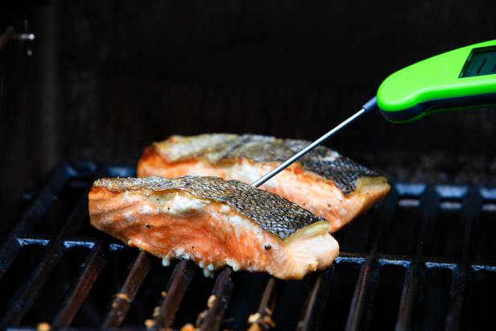
Photo: https://www.foodnetwork.com/how-to/articles/how-to-grill-salmon-a-step-by-step-guide

Za’atar Salmon
Modified, From https://www.washingtonpost.com/recipes/zaatar-salmon-charred-broccoli/
This recipe defies my rule against using unusual ingredients, because it uses Za’atar, a middle eastern staple that combines oregano, thyme, marjoram, sumac, toasted sesame seeds, salt, and sometimes orange zest and dill. However, I happen to keep a jar of the stuff handy because it enhances the flavor of just about everything.
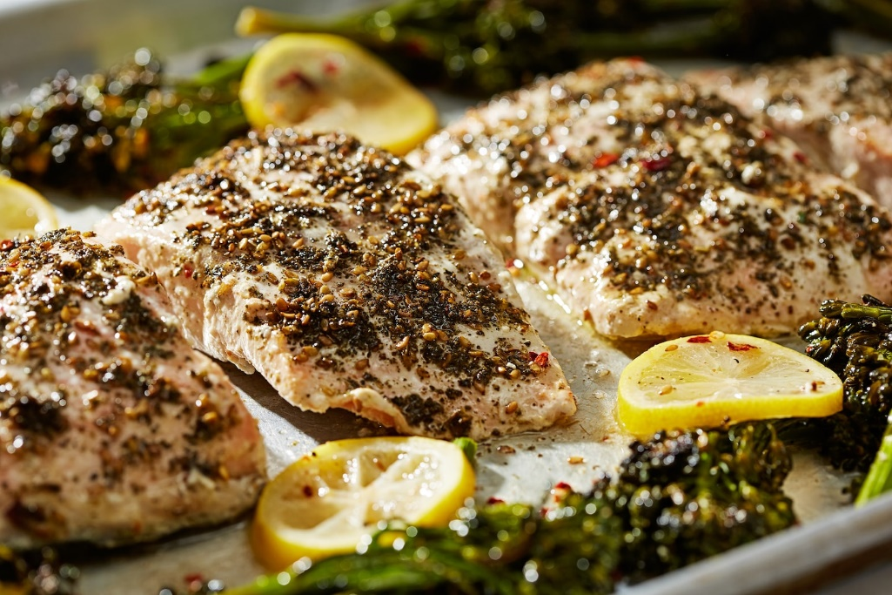
Ingredients
- 1/2 cup thick-style plain yogurt, such as Greek or skyr
- 2 lemons (1 juiced/about 2 tablespoons; 1 sliced)
- 1 teaspoon ground cumin, divided
- Fine salt
- 4 skinless salmon fillets, 6 to 8 ounces each
- Freshly ground black pepper
- 3 tablespoons extra-virgin olive oil
- 1/4 teaspoons crushed red pepper flakes, or more as needed
- 1 tablespoon za’atar
- 1/2 cup roughly chopped flat-leaf parsley, leaves and fine stems, for garnish (optional)

Directions

Oven: Position one rack in the middle of the oven and another 6 inches under the broiler heat source, and preheat to 400 degrees.

Combine yogurt, lemon juice, 1/2 tsp of cumin, and pinch of salt in a bowl. Season the salmon with salt and pepper, then add it to the bowl and coat the fish with the yogurt mixture.

On a sheet pan, toss the broccolini and lemon slices with the olive oil, remaining 1/2 teaspoon cumin, crushed red pepper, salt and pepper. Push the vegetables to the side and place the salmon in the center, skinned side down.

Roast on the middle rack for about 10 minutes, or until the broccolini and lemon are lightly browned at the edges, then flip the broccolini with tongs. Sprinkle the za’atar over the salmon, then return to the oven (rotating the baking sheet front to back) and roast for an additional 6 minutes, until the salmon is opaque.

Turn on the broiler, move the baking sheet to the upper rack, and broil for 2 minutes more for medium-rare. Transfer the baking sheet to a counter and let the salmon rest for 2 minutes before serving. Garnish with parsley or mint, if desired.

Easy-Peasy Cheesy Flounder
This is a quick and easy recipe you can produce in less than half an hour. It’s best for light, white fish such as flounder or seabass. Thin fish cooks fast, so be sure NOT to overcook it.
Ingredients
2 Tbsp Olive oil
¼ cup green onions or scallions
Sliced red or green pepper
Sliced hot peppers
1 Tbsp chopped garlic
1 doz cherry tomatoes, halved
1 Tbsp capers
Juice of half a lemon
¼ cup white wine or marsala
1 lb or 4-6 small filets of flounder
½ cup grated Parmesan or Romano cheese

Directions
Pour the olive oil into a large skillet and sauté the onions, peppers, garlic, tomatoes, and capers. Add lemon juice and wine. When vegies are soft, layer the fish on top of the mixture and spoon some of the liquid on top. Sprinkle cheese over fish. Place under hot broiler for 3 minutes. Watch carefully and remove fish as soon as cheese starts to brown, or fish reaches 125 degrees.
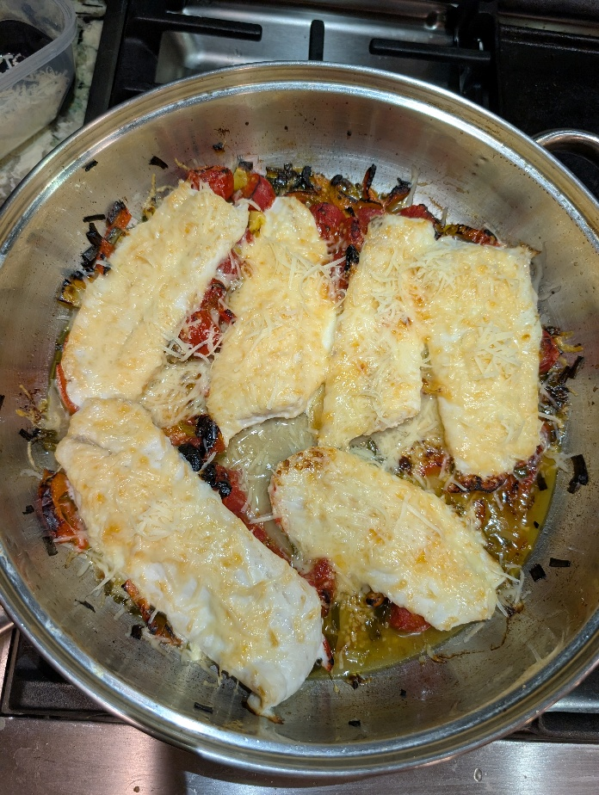

Monkfish
Monkfish has been called “the poor man’s lobster” because it is firm and tastes slightly like lobster. It is usually cut into steaks. Even after removing the skin, the meat has a thin membrane over it that must be removed. Remember to do this if your fishmonger doesn’t do it for you.
Ingredients
2 Tbsp Olive oil
¼ cup green onions, scallions, or leeks
1 Tbsp chopped garlic
1 doz cherry tomatoes, halved
Fresh herbs (parsley or cilantro)
1 Tbsp capers
Juice of half a lemon
¼ cup white wine or marsala
1 lb fish cut into 4-6 small pieces

Directions
Sauté the onions/leeks, garlic, tomatoes, herbs, and capers in olive oil. Add lemon juice and wine. When vegies are soft, push to the side and place the fish directly on the pan. Spoon some of the liquid on top. Monkfish is thick, so may take 10 minutes or so to cook but watch carefully and remove fish as soon as it becomes white, or reaches 125 degrees in the center of the thickest piece. Serve with rice, and spoon vegies and sauce on the rice
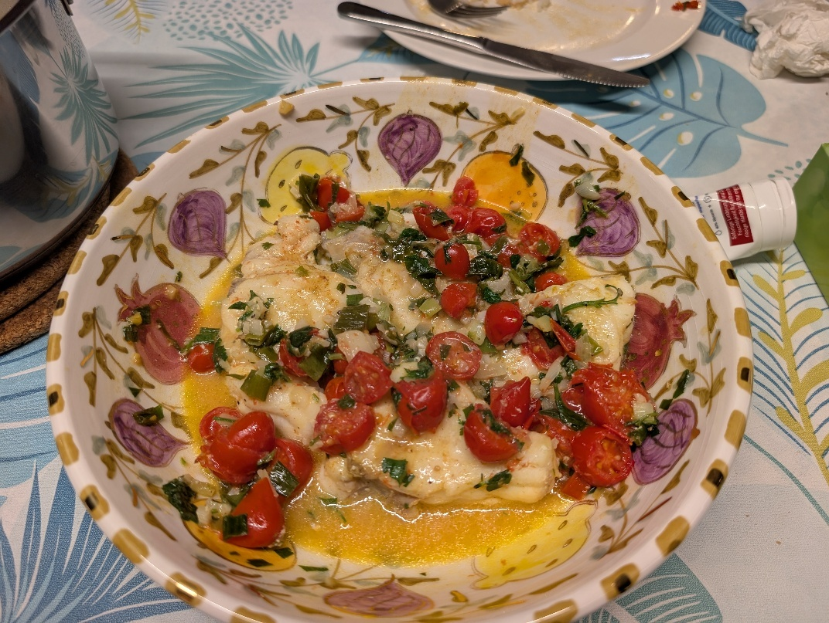
Foil-Baked Halibut (or any whitefish)
This is the simplest way to cook whitefish without too much fuss. The sauce is optional.
Ingredients
2 pieces fish, about 6-8 oz each (or cut a large filet in half).
If fish is frozen, thaw in plastic bag in cool water. Rinse, and pat dry.
Sliced onion
Sliced lemon
Salt & Pepper (freshly ground if possible)
6 oz white wine (5 for you, 1 for the sauce)

Sauce: melt ½ stick butter and mix with herbs (e.g. parsley, cilantro, basil; fresh preferred). Add a few TBSp each of wine, lemon juice, and chicken broth.

Directions
Preheat oven to 375 F.
Pour your glass of wine and sip while preparing dinner.
Place each filet on a separate square of aluminum foil.
Sprinkle with salt and pepper, and top with sliced onions and lemons.
Wrap foil tightly from top and ends, and place on baking sheet in oven.
If you want sauce, make it while the fish is baking.
Cook 20 min, then check. Fish is done when it is opaque and about 125 F.
If not quite done, open foil and bake for 3 more minutes.

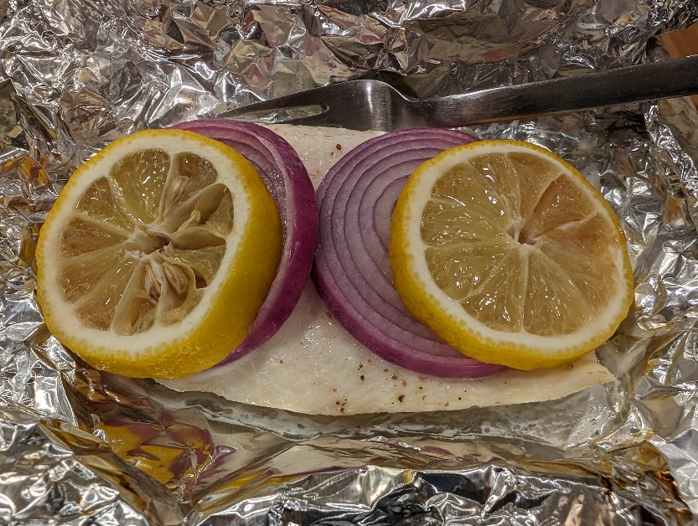

Fish Fillets en Papillote
One of the best fish meals I ever had was on the back deck of a Russian hake trawler, off the coast of Oregon. I had boarded the boat three days earlier, courtesy of the US Coast Guard, and even though the weather was mild, I was severely seasick. For two days, I could not eat a thing, and stayed in my bunk bemoaning my misery. On the third day the first mate dragged me out of my bunk and down to the officer’s mess, telling me in Russian “Nada kushyat!” (you must eat!). I sat and watched while they passed around some rice and sauerkraut (about the only vegetable that would keep for months at sea). Then the cook brought in a giant bowl of soup, with a large fish head sticking out of it. I felt my stomach starting to roil. Then the mate reached in with a spoon, gouged out one of the fish’s eyes, and popped it in his mouth with a large grin. I completely lost it. I jumped out of my seat, ran out the door, up the stairs and out onto the deck and heaved my stomach contents over the side of the ship. That wasn’t the best fish meal, that was to come later.
After I had got my sea legs, about a week later, I was out on deck watching the crew drag up a giant trawl net containing about 15 tons of Pacific hake. Mixed in with them were a number of brown or red rockfish. The crew grabbed the largest rockfish, about 20 lbs, and set it aside. After they had dumped all the fish in the hold and reset the net, they started preparing it. First, they split the fish along the back, keeping the belly skin intact. After cleaning out the guts, they stuffed it with a large onion, sprinkled it liberally with salt and pepper, then wrapped it up in heavy brown paper, and tied it all back together with string. They placed the paper-wrapped fish into an empty wooden sauerkraut barrel, then inserted a steam hose that they had apparently diverted from some other intended use, into the barrel, and covered it with a heavy raincoat. Then we all went back to our work.
About an hour later, after the next trawl had been emptied and reset, the crew uncovered the barrel, pulled out the paper-wrapped fish, and laid it out on the deck. This is the same deck we have just dumped 15 tons of slimy fish on, stomped all over bloody fish guts in work boots, and dragged a heavy net over, before hosing it down with seawater. Spread out on the deck, the steaming fish smelled heavenly. At their invitation, I joined them, sitting on the slimy deck, and gulping down handfuls of steamy, flaky, white fish. A loaf of fresh brown bread appeared, and we all dipped large chunks of it into the hot fish-flavored juice sitting in the wrapper. I spent two more months on that ship, but hat meal was better than anything I ever ate in the officer’s mess.
This recipe is a variation on “steamed fish in barrel” and works well with cod or other white fish. By wrapping the fish “en papillote”, i.e. in paper, you seal in the moisture, steaming the fish and vegetables. Any light flaky whitefish will work with this recipe, and you can use any vegetables you want. Grate or slice them thinly so they will cook. I’ve seen this recipe in several books, but this one is adapted from the Washington Post. In keeping with my generalist approach, I avoid dictating specific amounts of ingredients and suggest using as much or as little as you like. You can cook this in an oven, but I cooked mine on the gas grill.

Ingredients
- Juice of one lemon
- Vegetables, sliced thin, or peeled with a carrot peeler. A mixture of any of the following works: carrots, zucchini, green or red pepper, onion, shallots.
- 2 tablespoons extra-virgin olive oil
- Chopped fresh herbs, such as thyme or parsley
- Chopped garlic cloves, about 1 tsp
- 4 (4-6-ounce) skinless, boneless fish fillets, such as cod. Or take two 1-lb fillets and cut in half.
- 2 Tbs butter
- 1/4 cup dry white wine, such as sauvignon blanc
Directions
Preheat oven to 400 degrees. Squeeze the juice from the lemon.
Slice vegetables thinly or using a vegetable peeler to make thin ribbons. In a large bowl, toss the vegetables, olive oil, lemon juice, half the herbs, some pepper and salt. Add an ounce of wine.
In a small bowl, mix together the butter, chopped garlic, and the remaining herbs.
Lay out four 12-by-16-inch pieces of aluminum foil. Place a layer of vegetables on on end of the foil, lay a piece of fish on top, and pour on a tablespoon or so of fluid from the veggie bowl. Top the fish with a spoonful of the herbed butter mixture.
Fold the foil over the fish and veggies, then fold up and crimp the edges.
Place the foil wrapped fish packets onto a baking sheet (two pieces per sheet). Bake for 10-12 minutes for thin fillets, or 15 minutes for thicker ones. Insert a digital thermometer through the foil into the fish to test for done-ness. Remove when they exceed 145 degrees F. The fish should be opaque and flaky, and the vegetables still slightly crisp. If not, continue cooking for a few more minutes. Place one packet on each plate and open them. Here's what the cod en papillote looks like before cooking.
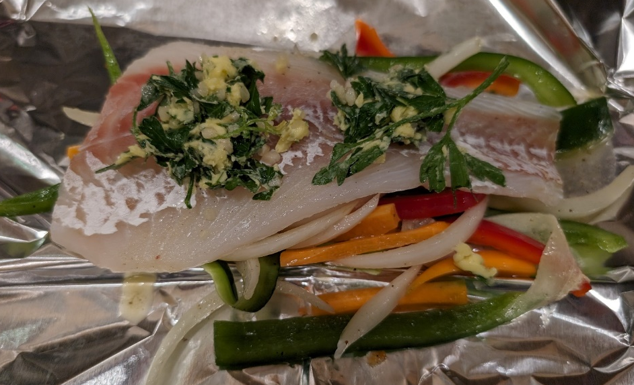
Rockfish with Light Orange Sauce Or Sebastes a l'orange
When I lived in Alaska, I would go fishing in my kayak. After launching from the beach, I paddled out to a rocky island or cliff where kelp was growing, in about 20 to 40 feet of water. At the outer edge of the kelp bed, I grabbed a large blade of kelp and wrapped it over my kayak to keep me in one place, just like otters do when sleeping. Then I dropped a heavy jig to the bottom and bounced it up and down. Soon I felt a sharp tug, and I tugged back to set the hook. As I reeled up, the fish jerked and twitched, pulling my rod down with each movement. As it neared the surface, I looked down into the water to see that I had caught a three-to-five-pound black rockfish Sebastes melanops. Slowly, I lifted the fish into the kayak and dislodged the hook, careful to avoid being stabbed by the sharp spines. Within an hour, I had caught three or four fish, and it was time to paddle back and call it a day. At home, I filleted the fish, cooked what we needed for dinner, and froze the rest in vacuum-sealed bags. Along with salmon and halibut caught at other times, I kept my freezer full, and my family fed for the whole year.
This recipe works with any firm white fish such as snapper, grouper, or rockfish
Ingredients
2 filets (total 1-2 lbs)
Salt & pepper (about 1 tsp each), dash of nutmeg
Sauce: Mix together 3 Tbs olive oil, 2 Tbs orange juice, and 1 tsp grated orange rind (zest). Add some grated ginger if you like.
Directions:
Preheat oven to 350 °F (177 °C). Oil a baking dish and lay fish filets in one layer. Sprinkle with salt and pepper. Pour sauce over top and sprinkle with nutmeg. Bake for about 20 min, or until it reaches 125 °F and flakes easily.
Source: Fish Dishes of the Pacific, from the Fishwife, by Shirley Rizzuto. Hawaii Fishing News, Honolulu, HI. 1986.
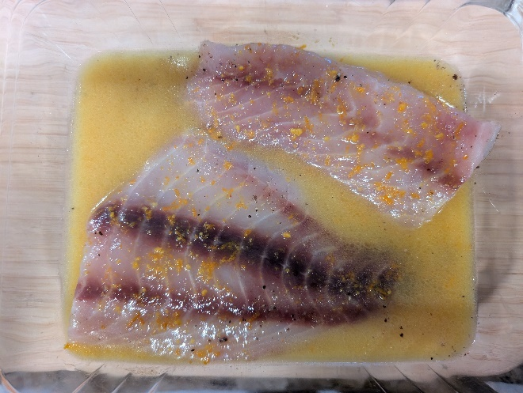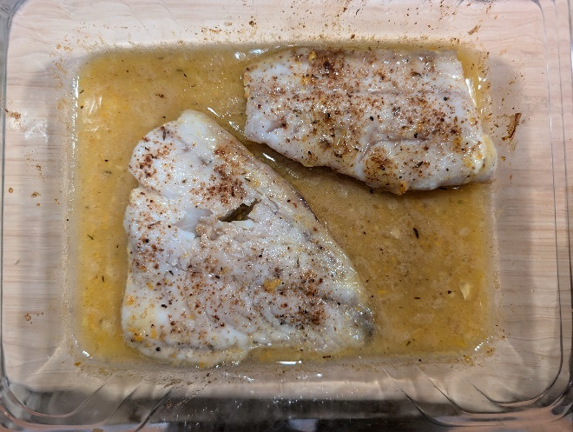
Air Fried Fish Fillets
You can use your air fryer to make crispy fish fillets. This recipe from the Washington Post (modified) used cod, but I used Alaskan rockfish and lingcod. Despite the fact that they had been in my freezer for over a year (but were professionally vacuum packed), both came out crispy on the outside and moist inside. The lingcod was particularly light and tender; I strongly recommend it. Serves 4-6. Leftovers can be refrigerated for up to 2 days; reheat in preheated air fryer for 2 minutes. Source https://www.washingtonpost.com/recipes/air-fryer-fish-fillets/

Ingredients:
- 4 (4- to 6 -ounce) fillets of cod or other white fish
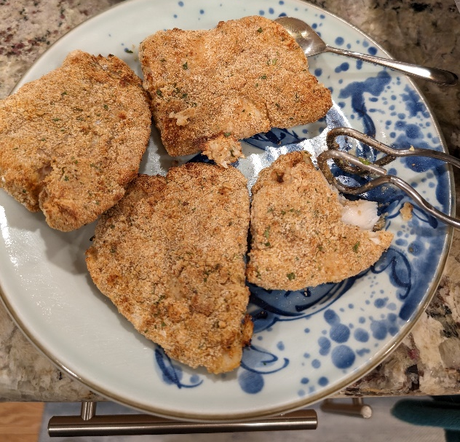
- 1/4 tsp table salt
- 1/2 tsp finely ground black pepper
- 1/4 cup all-purpose flour
- 1/4 cup cornstarch
- 1/2 tsp onion powder
- 1/2 tsp garlic powder
- 1/2 tsp paprika
- 2 large eggs plus 2 tablespoons water
- 1 TBSP hot sauce
- 2 cups breadcrumbs or Panko
- Cooking spray
- Lemon wedges
- Cocktail or tartar sauce

Directions

Thaw fish if previously frozen

Spray the air fryer basket with cooking oil. Set the temperature to 400 °F and preheat .

Set out three bowls or shallow baking dishes. In bowl 1, mix together the flour, cornstarch, onion powder, garlic powder, paprika, salt and pepper. In bowl 2, whisk together the egg, water and hot sauce. Put the panko/breadcrumbs in bowl 3.

Coat each piece of fish with the flour mixture, then dip it into the egg, then place it in the breadcrumbs, covering the fish on all sides. Place the fillets on a baking rack and lightly spray them on one side with cooking oil.

Place the fish in the fryer basket in a single layer and cook for 5 minutes. Then, turn over the fillets, spritz with the cooking spray, and cook for another 5 minutes, or until internal temperature reaches 125-130 °F. Fish should be golden and flake easily with a fork. If not, cook an additional 1 minute.

Serve the fish with lemon wedges and cocktail sauce (see NOTES).

Jansson's Temptation
This is a “traditional” Swedish dish that dates from the early 20th Century that is basically scalloped potatoes with fish. It may have been named after a gluttonous opera singer, or a movie of the same name, but whatever the source, it is a hearty winter meal that often appears as part of a Christmas smorgasbord. The original recipe calls for sprat, but some recipes substitute anchovies (a mistranslation of the Swedish word for sprat - ansjovis), but I prefer it made with pickled herring. This recipe is slightly modified from Food.com. Total cooking time varies among recipes, but most suggest that you pre-cook the potatoes for 10-20 minutes before adding the cream, and 30-40 minutes afterwards.

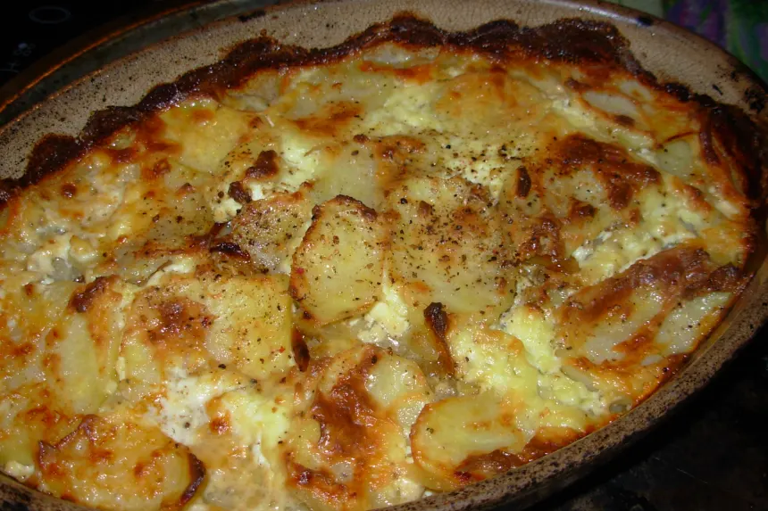
Ingredients
- 2 -3 large onions, sliced
- 3 Tbsp butter
- 6 russet baking potatoes, peeled and sliced thinly
- 2 cans (4 oz) anchovy fillets or 8-oz pickled herring, drained and chopped (save the juice)
- 1 ½ cups heavy cream
- salt and pepper

Directions
- Preheat oven to 400 degrees F.
- In a skillet, cook the onions in 2 Tbsp of butter until golden
- In a buttered 2-3 quart baking dish (13 x 9), layer 1/3 of the potatoes, 1/2 of the onions, 1/2 of the fish, salt and pepper; then another similar layer, and finally, the last third of potatoes.
- Drizzle the fish juice over the potatoes and dot them with the remaining butter.
- Bake the casserole on the middle rack for 20 minutes.
- Pour the cream over the potatoes, reduce heat to 300, and bake for 30-45 minutes more or until the potatoes are tender.
- Allow it to cool slightly before eating.

Avocado Toast with Sardine Salsa
My students asked me to come up with an alternative to tuna salad, so this is it. It is basically tuna or salmon salad with sardines. I make it with hot banana peppers and lime, like a ceviche, but the fish is already cooked in the can. Top it off with canned chopped tomatoes and serve on toast or crackers. This recipe is adapted from allrecipes.com. https://www.allrecipes.com/recipe/228895/avocado-salsa-and-sardine-frenchy/
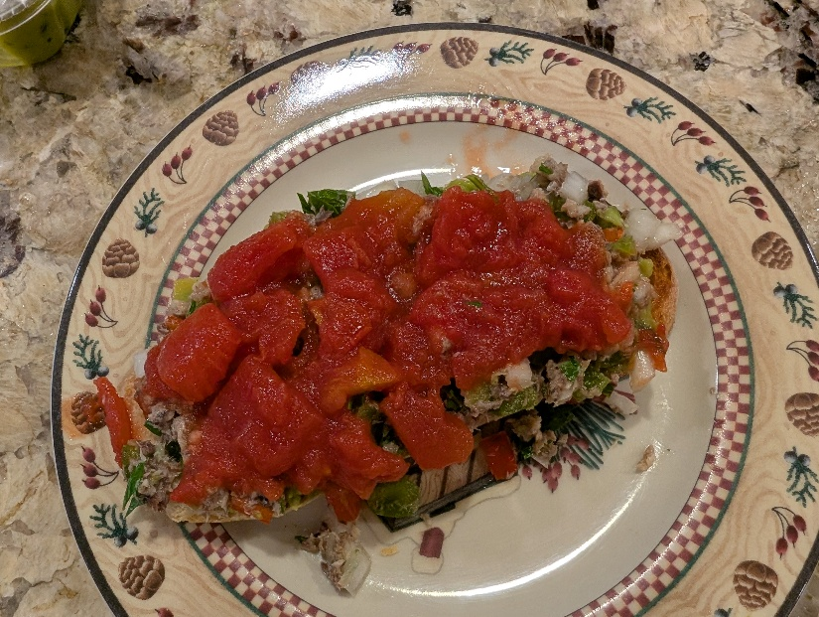
Ingredients
Bread, flatbread, or heavy crackers
Olive oil
One can of sardines
Green pepper
Onion
Garlic
Juice of one lime
Can of diced tomatoes
Avocado – mashed, with lemon juice, or pre-made guacamole spread
Directions:
  - Place some bread (brushed with olive oil) in your toaster or toaster-oven or use heavy crackers or flatbread.
  - Chop up green peppers, hot peppers, onion, and garlic, and add lime juice
  - Mash up the sardines (bones and all) and mix with salsa
  - When toast is ready, spread a layer of guacamole, top with fish-salsa mix, and top off with some diced tomatoes.

Bay Scallops Linguini
I borrowed this recipe from https://club.cooking/recipe/bay-scallops/
Ingredients
- 1 1/2 tablespoons olive oil
- 1 lb frozen bay scallops, thawed, rinsed and patted dry
- 4 cloves garlic, minced
- 1/2 cup white wine
- 2 TBS lemon juice
- 1/4 cup chopped parsley
- 4 TBS butter, sliced or cubed
- 1 pinch cayenne pepper
- Salt & Pepper to taste

Directions
- Heat olive oil in a skillet over high heat. When oil begins to smoke, add scallops. Cook for 30 seconds without stirring.
- Toss scallops in pan and stir in garlic. Cook and stir about 30 seconds.
- Stir wine and lemon juice into scallops, bring to a boil, and cook for about 30 seconds.
- Drink a glass of wine
- Stir parsley and cold butter into scallops and remove from heat. When butter melts, stir in salt, black pepper, and cayenne pepper.
- Spoon scallops over pasta and serve immediately.

Calories (kCal) | Protein (g) | Total Fat (g) | Sat Fat (g) | Carbs (g) | Cholesterol mg | Sodium mg
528 | 45 | 25 |  | 24 | 149 | 780

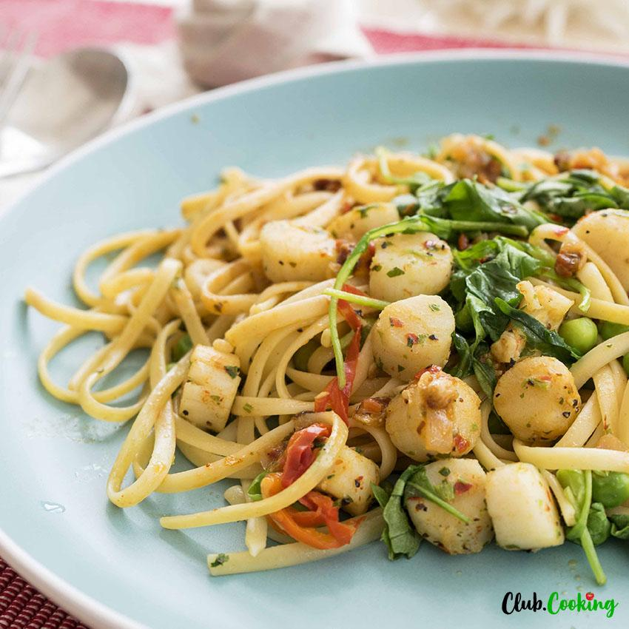

Ken Chew’s Scalloped Oysters

Dr. Ken Chew was my first PhD advisor at the University of Washington. He loved to cook, so his classes on the biology of mollusks were mostly recipes.

Ingredients:
2 pints shucked oysters in liquid
I pkg saltine crackers
2 cups grated cheese
1 onion chopped
Milk
Worcestershire Sauce
Butter

Directions
  - Preheat oven to 350 F
  - Drain and retain oyster liquid. Rinse oysters in cold water.
  - Saute 2-3 dozen crackers in 2-3 TBsp butter
  - In deep casserole dish, layer
    - Half the crackers
    - 1 pint oysters
    - Grated onions & cheese
    - Another pint oysters
    - Remaining onions & cheese
    - Top with remaining crackers
  - Mix oyster juice and milk to make 1 cup fluid
    - Add 2 TBsp Worcestershire sauce
    - Pour into dish
  - Bake 30 min or until fluid evaporates

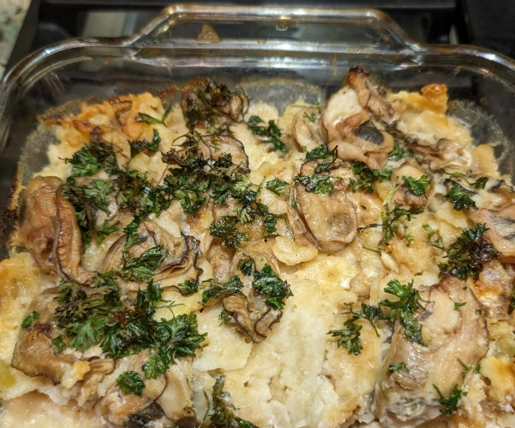

Steamed Mussels with Garlic Bread
One of the easiest seafood meals to prepare. This can feed a couple of people or a crowd. Serve as an appetizer or a main course.
Ingredients
- 4 lbs Mussels (cleaned)
- 3 cups white wine (2 for cooking, 1 for drinking)
- 4 TBsp Butter – 2 for mussels, 2 for garlic bread
- 1 onion, chopped
- 1 clove garlic, minced or chopped
- Fresh parsley
- Grated Parmesan or Romano cheese
- French or sourdough bread
Directions
- Garlic Bread:
  - Mix softened butter, chopped garlic and parsley
  - Slice bread, butter slices, place on cookie sheet lined with aluminum foil
  - Bake at 400 °F for 10 minutes; add grated cheese for last two minutes
  - For more browning, increase to 425 °F for 2-3 minutes
- Mussels:
  - Add 2 Cups wine and butter to a deep pot, add mussels
  - Bring to boil for 4 min, or until all shells pop open
  - Drink 1 cup wine while cooking
Eating
- Remove mussels from shell with fingers or fork
- Hold by the “beard”
- Dip garlic bread in juice
- Enjoy!
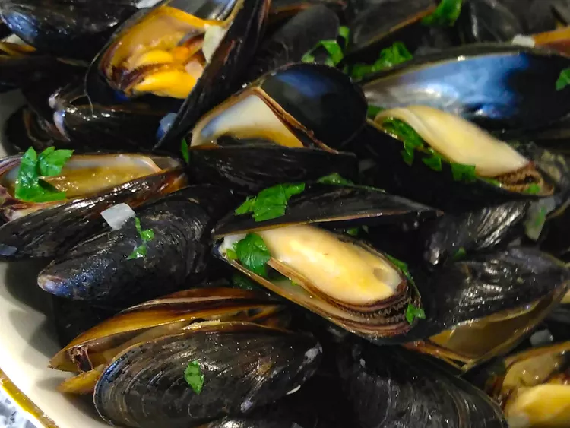
What to do with leftover salmon (or halibut, or any fish)
I usually cook enough fish for two meals, plus extra. I can tolerate reheated leftover fish for one day. On the third day, I use the extra to make fish salad. In the recipe below, I don’t give amounts. Use whatever suits you.
Salmon or Whitefish salad
Crush up the leftover fish in a bowl
Add something crunchy (chopped celery or green/red pepper)
Add something sweet (pickle relish)
Add something spicy (curry or mustard powder)
Add something savory (Celery seed or cumin)
Add something green (chopped fresh herbs, e.g. parsley or cilantro)
Add something sour (lemon juice)
Add something creamy (mayo, yogurt, or olive oil)
Mix together, spread on toast.
Enjoy

Even Better - Air Fryer Patty Melt
Butter the outsides of two pieces of bread. Cover the inside of one with fish salad.
Add sliced cheese, and maybe a tomato slice. Top with the other piece of bread.
Place in pre-heated air fryer (400 F) for 3 minutes, turn over for 3 minutes more.
Enjoy!

